Jawab

**Nomer 1 a**

import java.awt.Graphics;

public class utsjawaban1a extends java.applet.Applet {

public void paint(Graphics g) {

g.drawOval(25,25,200,200);

int xPts[] = {25, 125, 225, 125 };

int yPts[] = {125, 25, 125, 225};

g.drawPolygon(xPts, yPts, xPts.length);

g.drawRect(75,75,100,100);

int xPts2[] = {75, 125, 175, 125 };

int yPts2[] = {125, 75, 125, 175};

g.drawPolygon(xPts2, yPts2, xPts2.length);

}

}

jawaban

**nomer 1.b**

import java.awt.*;

public class utsjawaban1b extends java.applet.Applet {

public void paint(Graphics g) {

g.drawRoundRect(25,25,300,200,45,45);

int xPts[] = {25, 100, 175, 100 };

int yPts[] = {125, 25, 125, 225};

g.drawPolygon(xPts, yPts, xPts.length);

int xPts2[] = {175, 250, 325, 250 };

int yPts2[] = {125, 25, 125, 225};

g.drawPolygon(xPts2, yPts2, xPts2.length);

g.drawLine(25,125,325,125);

Font f = new Font("TimesRoman", Font.PLAIN, 24);

g.setFont(f);

g.drawString("A",90,100);

g.drawString("B",240,100);

g.drawString("C",90,170);

g.drawString("D",240,170);

}

}

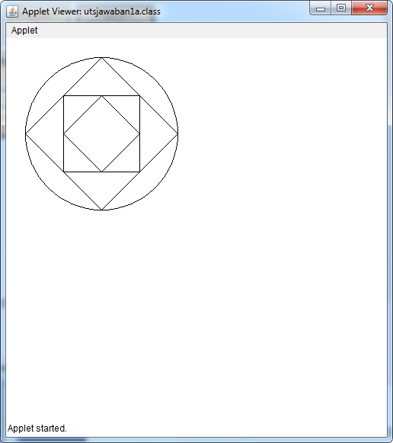

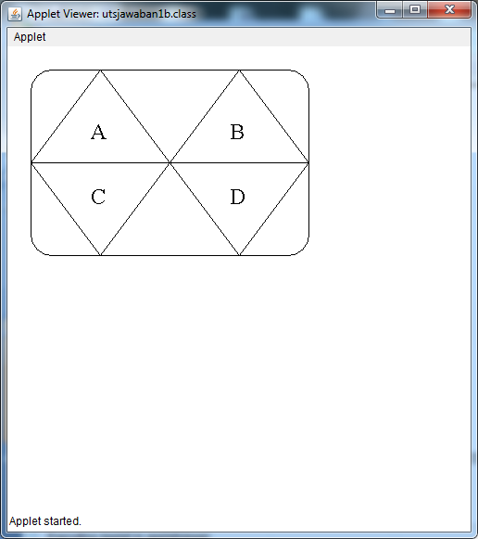

**Jawab nomer 2b**

import java.awt.*;

public class nomer2 extends java.applet.Applet {

public void paint(Graphics g) {

int a2=500;

int b1=500;

int b2=0;

int a1=500;

for(int i=0;i<25;i++)

{

a2=i*20;

b1=i*20;

g.drawLine(a1,b1,a2,b2);

a1-=10;

}

g.drawRoundRect(10,260,230,230,50,50);

}

}

